
Land Information Ontario (LIO) Warehouse
Data Class Name: Crown Land - MNR Acquisitions
Documentation
Produced by: Information Access and Information Management Policy Unit
Ministry of Natural Resources and Forestry
Date: July 27, 2015

Purpose

This document provides additional information to support the use of geospatial data. The Physical Model Diagram provides a visual representation of the relationships in the data class. The Data Change History lists all the modelling and access changes that have occurred during the lifecycle of the data class. A data description identifying table and field names is available upon request.

Need Assistance?
Please contact LIO Support at lio@ontario.ca or 705-755-1878 if you require help.

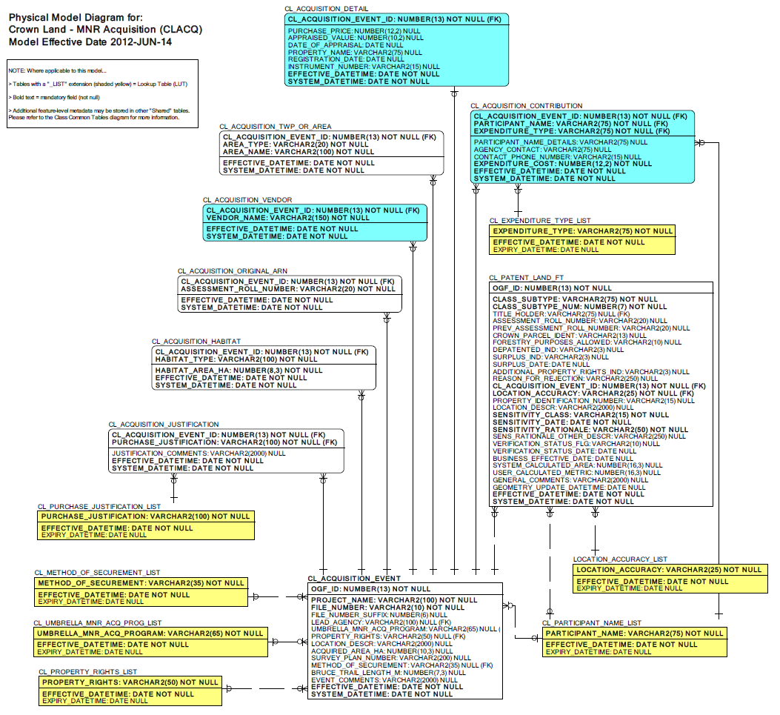

Data Class Change History

Data Class Name: Crown Land - MNR Acquisitions
Data Class Short Name: CLACQ
Date  YYYY-MM-DD | Details of Change
2009-01-06 | New Column: PROPERTY_IDENTIFICATION_NUMBER was added to table PATENTED CROWN
2008 | Column added PATENTED CROWN.PROPERTY_IDENTIFICATION_NUMBER
2007 | Table: Added: Habitat Type-  Added table Habitat Type with habitat area also included. Use can enter multiple habitat types for an acquisition.
2007 | Lookup Table: Added: Purchase Justification-  Added table Purchase Justification, with justification details also included so the user can enter many purchase justifications for an acquisition.
2007 | Table: Relationship changed: Patent Land and Acquisition Event-  Changed the one to many relationship to be one acquisition event relates to many patent land parcels.
2006 | NEW Data Class
Data Description
Please refer to the metadata record for the data description..

